# CHAPTER 1

# INTRODUCTION

## Rationale of the study

In this generation, the traveling and adventure industry is getting in demand. Nowadays, more people are looking for outdoor adventures that they never tried in other places. travelling, or having outdoor activities will give us benefits like emotional, physical and intellectual benefits. According to Nancy Wells(2015) outdoor settings reduce stress anxiety and depression. Spending time on travelling increase positive moods and releases all the stress in the body. Travelling also provides physical benefits: reduces blood pressure and weight loss by hiking, biking or going out in the mountains. Outdoor activities lead to an increase of confidence, improve creativity and better self-esteem, natural settings rejuvenate and calm minds and increase positive effect. In contrast, artificial environments may cause feeling of exhaustion, irritability and impulsivity (Lepp, 2009).

With the help of the internet, they can easily find the adventures they want to go and find the best website that can offer safety and best travel guides. There are many problems in booking travels online that is not safe.Also, many of the travel guides are not licensed to be a guide and their safety is at risk.One of the safest way to deal with outdoor adventures is to be not alone (Azizi, 2017).

The system that the researchers created are for the adventurers to have a crew to guide them on their adventures and making their travel booking(s) easier with the help of the geo mapping service the adventurer can easily see and identify the location of the adventure sites. And for the tour guides to have an easier access to their target market and make a profiling for them in the website that the adventures can interact with.

Furthermore, the researchers included a separate tracking application that helps the crew and adventurers keep an eye with each other during an adventure. The application being used is android-based for smart phone users that will send one’s location to the system’s database.

**1.2 Statement of the problem**

**1.2.1 General Objective**

The study aimed to develop LATAGAW: Philippine Adventure Consultants booking system with geo-mapping and a separate tracking application for the adventurers and crew utilized during an adventure.

**1.2.2 Specific Objectives**

The researchers should be able to:

1. Determine the adventurer-crew relationship on how they inquire and book different adventure sites.

2. Design a booking system with geo-mapping system of different adventure sites and use a mobile application to track the adventurers and crews during an adventure.

3. Test and evaluate the system.

**1.3 Significance of the study**

The traveling industry is getting bigger and many people like to try different types of adventure. Technology right now is fast evolving and adventurers want to see the places they want to go and have a fast transaction. In this technology, we used geo mapping sites so that the adventurers can view the places they want to go. This generation depends on the internet to search for places. This research will benefit the following:

**Adventurers** – the system lets them choose what types of adventures they want to try and can choose the location they want to make the adventures. They can make a booking based on the available dates.

**Crew** – the system helps the crew to profile themselves and segregate them in their proficiency as a travel guide like Scuba Diver, Mountain Climber, etc. They can easily acquire their target customers/adventurers in this system.

**Department of Tourism –** this system helps the department of tourism as an important contributor to the economic growth of the country. This system will promote the best adventure spots in Cebu.

**Researchers** - this study helps the researchers develop their skills in web developing and programming.

**Future Researchers**- the study will be used as guide in improving or making a better traveling system in the future and it can help the traveling and tourism industry to make it better.

**1.4 Scope and Limitations**

This study is for the people who wants to go travelling, exploring, and do extreme adventures in Cebu. The system’s main feature is the booking system that helps them book the different kinds of adventures and they can use the geo mapping system to help them locate the adventure sites easily and the tracking application used during an adventure to help them keep an eye from each other and alert if someone’s in trouble.

The limitation of this study is that the system only covers the adventure sites and locations within Cebu. The system is web based and works best if accessed through a desktop computer using a web browser.

On PAC crews’ dashboard, they can manage packages (create, update, and delete package). They can upload and remove photos and videos. The crew profile will be made public so the adventurers can review, rate and comment on a package after they’ve experienced it themselves. Lastly, if they wanted to update the map, they will inquire the admins of the system for it to be updated.

The logged in adventurer can book, rate and comment the packages. After they have chosen a package, they will choose a date, add guests(s) (if they have any) then proceed to payment. They can also receive notifications regarding the status of their booking(s), receive updates and promos.

The system’s tracking application for the adventurers and crews is utilized during an adventure. It’s a real-time Global Positioning System (GPS) tracker that will send the locations of its users to the database. The application will alert send an alert to every user on that adventure if someone had been separated from the group for distant radius from the crew’s lead guide.

The limitation of the tracker application is that it is limited only for android users and can only be used with a smart phone. Also, the application can’t be used in all adventures, it’s only bound for adventures that are on land or if they will do canyoneering, they can put their smart phones in a dry bag. An internet connection is needed in order the tracking application to be functional.

# CHAPTER 2

# RELATED SYSTEMS

This chapter discusses existing literature and systems related to the study. The gaps and what has already been done will also be presented in this chapter.

**Airbnb**

Airbnb is an online marketplace and hospitality service, enabling people to lease or rent short-term lodging including vacation rentals, apartment rentals, home stays, hostel beds, or hotel rooms. The company does not own any lodging; it is merely a broker and receives percentage service fees (commissions) from both guests and hosts in conjunction with every booking. It has over 3,000,000 lodging listings in 65,000 cities and 191 countries, and the cost of lodging is set by the host.(Sangeet, 2014)

**Flipkey**

FlipKey is an online vacation rental marketplace. It is a subsidiary of TripAdvisor. In 2016 the company listed more than 300,000 properties in 179 countries. Its headquarters is in Boston, Massachusetts, United States. Although rental owners are verified by the company's staff before being added to the FlipKey website, the site relies heavily on traveler reviews of rental properties. FlipKey also publishes ratings for travel-related items such as food blogs and in the United States it provides ratings of national historic sites. (Kelly, 2015)

**G adventures**

G Adventures (Formerly Gap Adventures) is a travel company and offers socially and Eco-tourism. The company is based in Toronto, Ontario, Canada. According to Tour Radar, G Adventures offer 686 different tours in 134 countries. (Stanleigh, 2013)

**Life 360**

Service that tracks users' location and alerts family members of their safety status extends beyond the iPhone and Android devices.In addition to tracking family members on a map (depending on a person's position, the app can pinpoint their precise location or locate them within a few tenths of a mile) Life360 provides a lifeline in the event of an emergency.(Dickenson, 2011).

**Safety and precautions**

Outdoor activities involving students should not be stopped but extra precautionary measures need to be taken to minimize potential risks. Planning and knowing is one of the most effective methods to avoid any accidents. “Information and knowledge on how emergency situations must be dealt with should be prepared beforehand to ensure that everyone involved knows their role in the face of an emergency” (Azizi, 2017). If your trip will be strenuous, get into good physical condition before setting out. If you plan to climb or travel to high altitudes, make plans for proper acclimatization to the altitude.

If you get caught in an unexpected thunder storm, shelter under a clump of low trees and away from metal objects. Don’t stand under tall trees as these are more likely to attract lightning. Thankfully, lightning strikes are rare but it’s best to be on the safe side.

According to (Smith, 2014) Basic Precautions You Can Take to Ensure a Safe Adventure Abroad, no place in the world is 100% safe (simply watch your hometown nightly news), and you always have to use common sense, but remember that most countries in the world have far lower crime rates than the United States and that you will be far less likely to be affected by violent crime in Tokyo, Taipei or Abu Dhabi than you will be in Philadelphia, New Orleans or Dallas.

Furthermore, according to  (Carlson & Cook, 2007) Fun, Safety, Camaraderie, and Outdoor Adventure at the Hero’s Journey Program staff should understand and harness the power of physically and emotionally safe social environments for adolescents living with serious illness to get to know each other more deeply and to share their experiences. Second, utilizing and reflecting on outdoor challenges can enhance feelings of camaraderie and safety through structured relationship-building activities. Third, camps should consider using the Hero's Journey model to intentionally program for participants' transformational experiences as youth build capacity, character, and community.

**Extreme adventures**

In psychology, the study of extreme, risk or adventure sports (e.g., bungee jumping, skydiving, mountain biking, downhill skiing, mountaineering and rock climbing), has generally concentrated on the excitement- or thrill-seeking associated with risk taking during these activities. This may have resulted, in part, from the development of psychological measures such as the Sensation Seeking Scale (Zuckerman, 1971). As a result, with other motives for taking part in adventure sports being largely ignored, there has been a gap in the literature which is only recently being addressed by researchers (John H. Kerrb , Susan Houge Mackenzie, 2012).

Engaging youth in outdoor adventure recreation has been a means to build confidence, trust in oneself and others, and mastery of skills and abilities (D’Amato &Krasny, 2011). Additionally, attention has been given to the connection between different kinds of recreation and positive youth development as well as ways young people can develop bonds with the natural environment. Studies have also indicated a link between childhood outdoor recreational experiences and pro-environmental attitudes in later life. more positive perceptions of natural environments and phenomena and a heightened interest in environmental professions Understanding encounters with the outdoors is important for recreation scholars and planners, particularly when considering the needs of individuals and groups who have had little prior experience with natural environments. Outdoor adventure recreation activities take place in a variety of settings, including forests, lakes and waterways, backcountry trails, state and national parks, mountainous terrain, and remote wilderness areas.(D’Amato &Krasny, 2011).

**Adventure guides and their roles**

The literature about tour guides identifies a wide diversity of roles. To Cohen (1985), guides have an instrumental role, an interactional role, a social role and a communicative role. To Weiler and Davis (1993), guides are also motivators and interpreters of the environment. Pond (1993) develops Cohen’s classification in a more detailed way and believes that guides need to be: responsible leaders; educators, helping guests in their limitations; ambassadors of hospitality; hosts creating a comfortable environment for guests; and social facilitators. Moreover, Holyfield and Jonas (2003) and Sharpe (2005) believe that adventure guides have an extra emotional managerial role. ‘‘Legally, the outdoor leader is responsible for the learning, the safety, and the positive well-being of the group members. Morally, the outdoor leader helps the group members to create, identify, work towards, achieve and share common goals’’. In adventure tourism, where clients are also looking for an emotional experience, it is part of the guide’s role to work towards this goal. It is part of the job to offer feeling cues to clients and to contribute to the generation of appropriate emotions (Arnould& Price, 1993; Holyfield, 1999). According to Holyfield and Jonas (2003), white-water rafting guides play a leading role in the construction of danger but also in its management, as well as the subordination of the clients who, in that environment, have less knowledge than the guides. This emotional role is part of the identity formation process of, for example, the ‘‘River God’’ or ‘‘Goddess’’ who are the entities able to control the natural environment and protect humans against misfortunes (Holyfield & Jonas, 2003). The perception of risk as constructed by guides is a technique to enhance their status, to create an ‘‘authentic’’ identity, and to provide a perception of adventure for their clients (Holyfield & Jonas, 2003; Palmer, 2002; Sharpe, 2005). To Holyfield (1999), the need to create emotional, exciting and thrilling experiences dominates the values of companies working with adventure activities.

Apparatus and method for an internet based computer reservation booking system

The goal of the system is to help merchants provide online real-time appointments for their customers. The system also provides merchants ability to manage the appointments, appointments made from telephone, walk-in or via the internet. Also the system aids the merchants in marketing since the system has a marketing tool, with the use of this marketing tool customer profiling and demographics are apprehended in the database and make use of the data gathered from the database to produce as mentioned in the publication a “highly targeted and effective marketing and promotional ad campaign.” (Chen, 2012) .

**Adventure and technology**

According to Mueller and Pell, the use of technology to support adventure has a long history; one only needs to think about the compass. However, technology also has the potential to reduce the sense of adventure, for example where previously a compass was needed to navigate to exotic places, planes now fly tourists there with ease. As such, adventure technology needs to reach a fine balance between supporting, but not impending, a sense of adventure.

To achieve this, adventure technology needs to be designed well, and this includes the design of digital technology. In recent years, industry developments have emerged that claim to support adventure, including adventure shops that, once promoting activities to take refuge from digital technology by engaging in the great outdoors, are now stocking a range of digital technologies aimed to support adventure. For example, there are GPS devices that support navigation, satellite phones that allow for communication in remote areas and action cameras that allow for the documentation of the adventure.

There also exists now smart watches that provide barometric and altimeter information, personal drones for aerial reconnaissance, guidance and documentation as well as emergency alert beacons. The rise of these products suggests that adventurers, who already have a history of engaging with non-digital support technologies such as compass, ropes and specialist clothing, can also embrace digital technology to support their experiences. However, most development advancements in this area are focused on technical improvements (such as better GPS accuracy), or on making existing technologies more robust (such as hard-shells for mobile phones).By contrast, in this paper, we focus on the role digital technology can play to support the adventure experience, as we find little understanding in this area**.** (Mueller & Pell,2016)

The assumed psychological change process is based on experiential learning (Kolb, 1984; Panicucci, 2007). Moreover, many scholars agree that the experience of a psychological disequilibrium at the beginning of the challenge is a necessary condition for a program to be successful. Participants should attain a mental state in between the ‘comfort zone’ and ‘panic zone’, which was labeled “groan zone” (Luckner& Nadler, 1997). Being in this zone is equipollent to a state of high attentiveness and receptiveness for new experiences. Bradley and Inglis (2012) also highlight that leisure activities that are challenging, demanding and require effort and skills are most suitable to facilitate positive development and personal growth among participants. (Mutz& Müller, 2016)

According to Nancy Wells, both physical activity and outdoor settings reduce stress, anxiety and depression. Spending time exercising in a park leads to an increase in positive moods and a reduction in cortisol levels, a hormone released when the body feels stress. Similarly, increased access to green space for activities such as walking decreases stress especially for children.(Wells, 2017)

According to Lepp, Outdoor activities lead to an increased confidence, improved creativity and better self-esteem,. Natural settings rejuvenate and calm the mind, improve outlook and increase positive affect. In contrast, artificial environments may cause feelings of exhaustion, irritability, inattentiveness and impulsivity, according to Resources for the Future. Outdoor time can even help you focus; 2009 research in the “Journal of Attention Disorders” shows that 20-minute walks through natural settings lead to improved concentration (Lepp, 2009)

**CHAPTER 3**

**TECHNICAL BACKGROUND**

This chapter discussed the fundamental algorithm, tools, and definitions that was relevant in this study.

**Server-side scripting language**

Server-side scripting is a technique used in web development which involves employing scripts on a web server which produce a response customized for each user's (client's) request to the website. The alternative is for the web server itself to deliver a static web page. Scripts can be written in any of a number of server-side scripting languages that are available Server-side scripting is distinguished from client-side scripting where embedded scripts, such as JavaScript, are run client-side in a web browser, but both techniques are often used together. (Wikipedia.org, n.d.). The back end comprises three parts: the **server,**your**database,**any**APIs,** anda**back-end web application,**software written via server-side languages. The server is a powerful computer that runs the back-end software, the database houses your site’s data, and the software communicates between the two. For example, if a user is updating a profile on a networking site, the server-side scripts will gather the information the user enters, the application will process it on the server, then interact with the database to update that information there. (upwork.com, n.d.).

**Relational Database Management System (RDMS)**

A relational database management system (RDBMS) is a database management system (DBMS) that is based on the relational model as invented by Edgar F.Codd, of IBM's San Jose Research Laboratory. In 2017, many of the databases in widespread use are based on the relational database model.A relational database management system (RDBMS) is a program that lets you create, update, and administer a [relational database](http://searchsqlserver.techtarget.com/definition/relational-database). Most commercial RDBMS's use the Structured Query Language ([SQL](http://searchsqlserver.techtarget.com/definition/SQL)) to access the database, although SQL was invented after the development of the relational model and is not necessary for its use.  (Esakkirajan, 2007)

**Online Payment**

An electronic payment system is a way of paying for a goods or services electronically, instead of using cash or a check, in person or by mail. The electronic payment system has grown increasingly over the last decades due to the widely spread of internet-based banking and shopping. As the world advance more on technology development, a lot of electronic payment systems and payment processing devices have been developed to increase, improve and provide secure e-payment transactions while decreasing the percentage of check and cash transaction. (Vielhand,2008).

**Geographic Information System (GIS)**

A geographic information system (GIS) is a system designed to capture, store, manipulate, analyze, manage, and present spatial or geographic data. The acronym GIS is sometimes used for geographic information science (GI Science) to refer to the academic discipline that studies geographic information systems and is a large domain within the broader academic discipline of geo informatics. What goes beyond a GIS is a spatial data infrastructure, a concept that has no such restrictive boundaries. (Madurika, 2017).

**Web Application Development Platform**

In computing, a web application or web app is a client–server software application in which the client (or user interface) runs in a web browser. Common web applications include webmail, online retail sales, online auctions, wikis, instant messaging services and many other functions. (Nations, 2014.).

**Global Positioning System (GPS)**

Global Positioning System or GPS is maintained by 24 satellites. It circles the globe once every regular interval, to provide worldwide position, time and speed of information. It makes conceivable to correctly distinguish locations on the earth by measuring distance from the satellites and also, enables you to record or make areas from places on the earth and help you to explore to and from those places.

**Location Based Services (LBS)**

Location Based Services is a software-level service that uses [location](https://en.wikipedia.org/wiki/Location_(geography)) data to control features. As such LBS is an [information service](https://en.wikipedia.org/wiki/Information_service) and has a number of uses in [social networking](https://en.wikipedia.org/wiki/Social_networking) today as information, in entertainment or security, which is accessible with [mobile devices](https://en.wikipedia.org/wiki/Mobile_device) through the [mobile network](https://en.wikipedia.org/wiki/Mobile_network) and which uses information on the geographical position of the mobile device.

# CHAPTER 4

# DESIGN AND METHODOLOGY

This chapter showed the outline of phases, sub-phases, proposed concept of the research, project plan, manage, control and evaluate computing of the research project.

**4.1 Conceptual Framework**

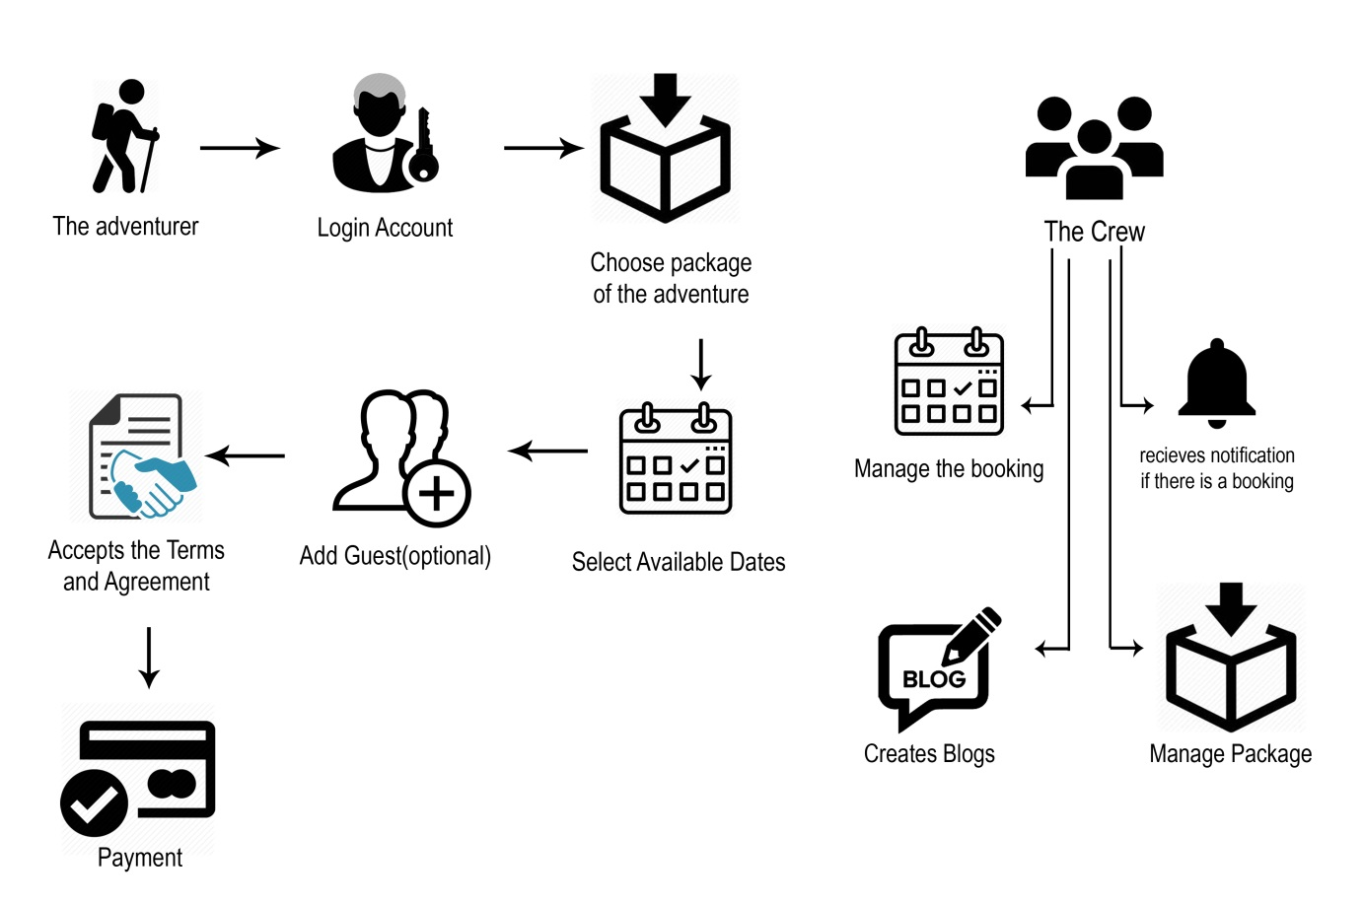The system is a web based booking system with geo mapping and GPS tracking via mobile application for Philippine Adventure Consultants focusing on the adventurer (customer) side. The adventurer will create an account to make a booking and they can receive notifications from the crews/admins. The user then can choose the available packages. When the Adventurer has already chosen a package that he/she wants to book, they will now proceed to the booking module where the adventurer will choose the date of the adventure, can add guest using the add guest in the booking module.

*Figure 1*.*1* Conceptual Framework for the Web application

The adventurer will agree to any terms and agreements, waivers, and cancellation policies between them and the company regarding safety, and other precautionary measures before an adventure will take place. The online payment will need any bank account information that would accept payments depending on what online payment partnership the system offers, but Credit card method is currently being used. On the Crew side, they are provided with their own accounts by the admin. They can manage the booking system in which they control how many adventurers can attend to that event. The crew also manage the packages they can create and update the package. The crew can create blogs to their profiles and to the website. The transactions and information is seen in Figure 1. Conceptual Framework

**4.2 Analysis and Design**

In this research, web-based and mobile-based approach is used to make the system and open-source PHP web framework (Laravel) is used in development of the web app system. The web-based system will also use MySQL for the primary database management system. For the mobile app, Firebase database storage is used since the requirement of this system requires real time update between adventurers and the crews for their locations. The system will be designed to be user friendly, dynamic and efficient loading of contents, plug-ins and modules. In Figure 2 it shows the current database structure of the application (ERD).

Below, shows all of the entities and relationships inside the database. Each has its important function in the continuous update and development the website to address the needs of the Philippine Adventure Consultants (PAC) crews, adventurers and the developers/researchers

The Adventurer(s) needs to have an account in order for them to book a package. They will first create an account if they if they haven’t had one yet or may register/login using Facebook or Gmail. Afterwards, they will choose a package which already consists of both adventure and its site. After they have chosen a package, they will select from the available dates and proceed to add guest(s) if ever they have any. Lastly, they will proceed to payment and will accept the terms and agreements of the company before confirming the payment to complete the booking.

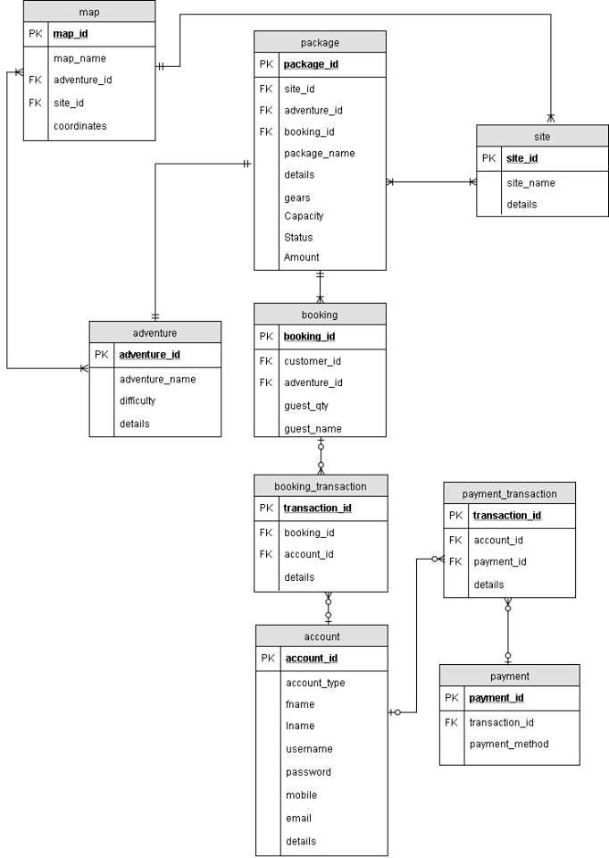

*Figure 2*. Entity Relationship Diagram

The Philippine Adventure Consultants crew (eg. Travel Consultants, Medics, Operation Manager, Program Manager, Technical Staff, and Lead Guides) will have to register an account in the website. Their account is going to be publicized so that the travelers will know who will be with them during the adventure. Credit card (BPI) is used for the online payment after a booking is verified for a fast and safe transaction. The travelers will pay a fixed booking payment (price depends on the adventure) for booking and the rest will be paid onsite. The PAC have many sites offered and currently offers 8 adventure categories which consisted of: canyoneering, trekking, mountaineering, diving, snorkeling, rappelling, biking and caving for their types of adventures. The adventures have various difficulty levels particularly categorized: Easy, Moderate and Extreme. The PAC travel guides are all licensed and make safety measures assessment before they explore the site. The travelers can check the various adventures and where they are located in Cebu using the geo map.

The researchers included a separate tracking application which will be used during the adventure to track the locations of the adventurers and crews. Before an adventurer can book an adventure (an adventure which the application is an inclusion), a waiver will be given to ask the adventurer to install the application including the guest(s) he/she included so it will be ready to use right before their adventure commence. A crew will send an invitation code to every user during the adventure so that they can join the group they will be tracked in.

**4.3 Development Model**

Planning Phase - brainstorming of new ideas happened to be incremented in the system. The concept and overview of the system was discussed among the group. Different kind modules and plug-ins are mentioned and are linked to the flow of the system. And it is by far the most crucial moment of this research.

Requirements Phase - the requirements for the modules are discussed and documented. Each module’s requirement is reviewed to ensure integrity of the software to be developed. Gathering problems that the website may face and coming up with solutions are discussed in depth in this phase.

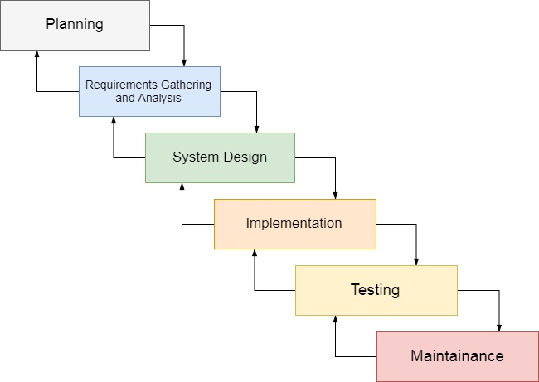

*Figure 3*. Modified Waterfall Model

Analysis and Design Phase - the design of the system are planned and discussed. We analyzed onto which software and platforms best fits to our system and if it is doable with our current skills and knowledge.

Implementation Phase - involved the development of the system. The requirements for each module will be followed and the design pattern discussed from the earlier phase will be carried out throughout the whole development cycle.

Testing Phase - requires the development team to test the software to make sure it meets the requirements set out from earlier phases. Checking for bugs and other errors will be carried out in this phase.

Maintenance Phase – The maintenance of the system is done by the current admins which are the researchers and developers of the system. They are also responsible for the revisions and any further updates of the system.

## 4.4 Development Approach

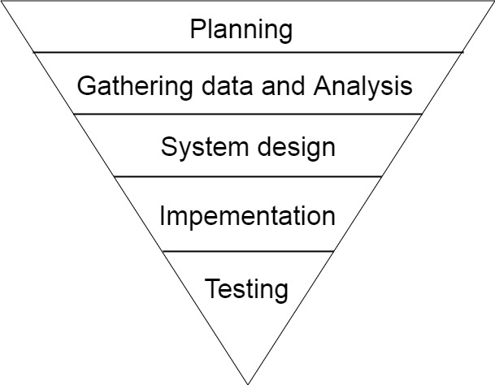

*Figure 4*. Top-Bottom Approach

The researchers used top-down approach of development. The first step was planning the system, to check whether the system is functional and check whether it’s beneficial to the company. Next phase is gathering data and analysis. This is where the detailed examination of the elements or structure of the project will be applied and thoroughly brainstormed, normally as a basis for discussion or interpretation. The system design phase, the researcher generates a user-friendly interface for easy use of a user and at the same time portray a professional look to the system. Next is the implementation, where the researchers created the fully functional system and making all plans into effect. Last is Testing, to identify system bugs or errors. This stage helped the researchers troubleshoot the system and improves it. The researchers used black-box testing to ensure that there will be no data structures or interface errors.

### **4.5 Software Development Tools**

Table 1.

*Software Development Tools*

|  |  |  |  |
| --- | --- | --- | --- |
| **Name** | **Front , Back end , Tester** | **Version** | **Use** |
| MySQL | Back end | 13.0.1601.5 | Database management for the data needed to be stored and retrieved. |
| Laravel | Front end, back end | 5.3.0 | The framework that will be used in developing the website. |
| Google Maps API | Front end, back end | 3.29 | allows the researchers to display maps in web site |
| Paypal | Back end | 1.0.4 | PayPal is the faster, safer way to send money, make an online payment, receive money or set up a merchant account. |
| BOOTSTRAP | Front end | 3.3.7 | For the front-end part of the system to make its GUI more user friendly |
| Fire base | Back end | 9.6 | It supports [social login providers](https://en.wikipedia.org/wiki/Social_login) Facebook, GitHub, Twitter and Google. Additionally, it includes a user management system whereby developers can enable user authentication with email and password login stored with Firebase |
| XAMMP | Back End | 7.1.7 | For managing the database easier and to create a local web server for testing and deployment purposes |
| Android Studio | Front End  Back End | 2.3.3 | A development tool that includes every tools necessary to develop Android apps and games. |

# 4.6 Project Management

In developing the system, the researchers follow the schedule and timeline, segregates the responsibilities to the members and budgets the cost that will be used in this research.

# 4.6.1 Schedule and Timeline

Table 2

**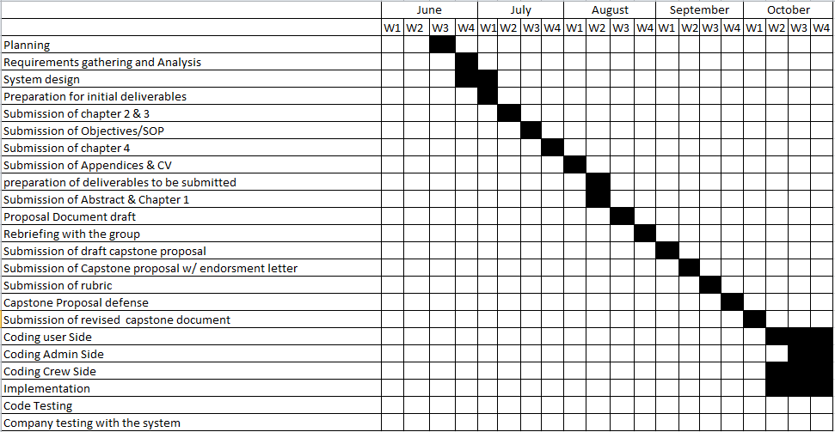***First Semester Timeline, SY 2017 - 2018*

Table 3

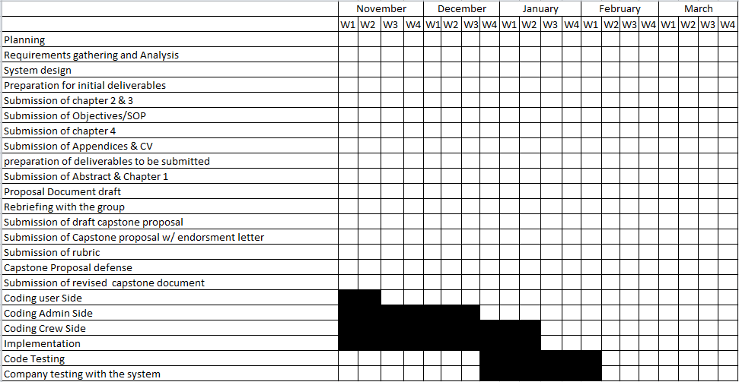Second Semester, SY 2017 - 2018

**4.6.2 Responsibilities**

In making the system work, every module is segregated to each member so that the system will be implemented at the right time.

Table 4

*Roles and responsibilities*

|  |  |  |
| --- | --- | --- |
| **Members** | **Roles** | **Responsibilities** |
| Mark Anthony Bioc | Front End Developer  Back End Developer | Mobile tracking app  Google maps API |
| Victor Gabriel Granada | Front End Developer  Back End Developer | Adventurer Module  UI design |
| John Roldan Sasing | Front End Developer  Back End Developer | UI/UX design  Pages Module |
| Albert Kho | Front End Developer  Back End Developer | Crew/Adventurer Module  DB implementation  UI/UX design  CRUD model  Google maps API |

### **4.6.3 Budget and Cost Management**

To accomplish this system the researchers, use this budget and cost management to avoid over expenses while doing the research.

Table 5

*Budget and Cost Management*

|  |  |
| --- | --- |
| **ITEMS** | **COST** |
| Printing (Bond Paper) | 800.00 |
| Binding (Hardbound) | 400.00 |
| Surveying | 200.00 |
| Folder/Sliders | 100.00 |
| Food/Beer | 12,000.00 |
| Web Domain | 3,000.00 |
| Laptop | 90,000.00 |
| Transportation | 1,500.00 |
| Miscellaneous | 1000.00 |
| **TOTAL** | **109,000.00** |

# 4.7 Verification, Validation and Testing

The researchers created questionnaires to survey within the University of San Carlos in order to gather data for the researchers to validate the system if it needs to be improvement or to implement new functions. The working system was tested by several chosen students, teachers and friends by invitation to find out and verify if our system is easy to use and how the respondents reacts and to the system. The respondents shared their opinions about the usage of the system.

The researchers used black-box testing to test the overall functionality of the system. With the use of the framework the testing is faster and efficient. User Acceptance Testing or beta testing will also be included wherein the researchers will test the system in the “real world” by intended users which is composed of 20 individuals from the University of San Carlos Talamban Campus students and faculties who are interested in outdoor adventures. The system will be tested by selected individuals in the University of San Carlos. The problems and flaws of the system will be fixed and updated.

**REFERENCES**

**Journal**

Aaron, R. F., & Witt, P. A. (2011).Urban students' definitions and perceptions of nature. Children, Youth, and Environments, 21, 145–167 retrieved from http:// [www.colorado.edu/journals/cye](http://www.colorado.edu/journals/cye)

(John H. Kerr & Susan Houge Mackenzie, 2012) Multiple motives for participating In adventure sports from science direct. Website: http://www.sciencedirect.com/science/article/pii/S1469029212000490

Mutz& Müller,( 2016) Mental health benefits of outdoor adventures: Results from two pilot studies from elsevier. Website: www.elsevier.com/locate/jado

Allman, T. L., Mittelstaedt, R., Martin, B., & Goldenberg, M. (2009).Exploring the motivations of base jumpers: extreme sport enthusiasts. Journal of Sport & Tourism, 14, 229e247

SandroCarnicelli-Filho, (2013) THE EMOTIONAL LIFE OF ADVENTURE GUIDES

(Kristi S. Lekies& Greg Yost & John Rode, 2015) Urban youth's experiences of nature: Implications for outdoor adventure recreation

Mueller & Pell, (2016) Technology meets Adventure: Learnings from an Earthquake-Interrupted Mt. Everest Expedition(Echtibi p.6) Murshid: A Mobile Tourist Companion

Ewert, A., Place, G., &Sibthorp, J. (2005).Early-life outdoor experiences and an individual's environmental attitudes. Leisure Sciences, 27, 225–239. http://dx. doi.org/10.1080/01490400590930853

**Web Article**

Azizi (2017) Take extra precautionary measures, don't stop outdoor activities From NST. Website:https://www.nst.com.my/news/nation/2017/05/2 40187/take-extra-precautionary-measures-dont-stop-outdoor-activities

(Smith, 2014) Basic Precautions You Can Take to Ensure a Safe Adventure Abroad fromnicaraguatefl. Website: [https://nicaraguatefl.com/basic- precautions-you-can-take-to-ensure-a-safe-adventure-abroad/](https://nicaraguatefl.com/basic-precautions-you-can-take-to-ensure-a-safe-adventure-abroad/)

(Chen, 2012) Apparatus and method for an internet based computer reservation booking system from Google. Website: https://www.google.com/patents/US20050267787#backward-citations

Stanleigh, Sean (April 4, 2013). ["Tourism Program for Latin America"](https://www.theglobeandmail.com/report-on-business/small-business/sb-tools/small-business-briefing/article10778520.ece). Globe and Mail.Retrieved .from Wikipedia. Website: Https://en.wikipedia.org/wiki/G_Adventures

Lagorio, Christine (2010). ["Brian Chesky, Joe Gebbia, and Nathan Blecharczyk, founders of AirBnB"](http://www.inc.com/30under30/2010/profile-brian-chesky-joe-gebbia-nathan-blecharczyk-airbnb.html). [Inc.](https://en.wikipedia.org/wiki/Inc._(magazine)) Retrieved from Wikipedia. Website: https://en.wikipedia.org/wiki/Airbnb

Dickenson (2011) “Life360 turns your smartphone into a lifeline” Retrieve from Wikipedia. Website: https://www.cnet.com/news/life360-turns-your- smartphone-into-a-lifeline/

Wikipedia.GoogleMaps.Retrieved from Wikipedia. Website: https://en.wikipedia.org/wiki/Google_Maps

John H. Kerrb , Susan Houge Mackenzie, (2012) [Multiple Motives for Participating in Adventure Sports](http://digitalcommons.calpoly.edu/cgi/viewcontent.cgi?article=1031&context=rpta_fac)Retrieved from digitalcommons. Website:http://digitalcommons.calpoly.edu/rpta_fac/31/

Wells, (2017) Physical, Social, Emotional & Intellectual Benefits of Outdoor RecreationRetrieved from healthyliving. Website: http://healthyliving.azcentral.com/physical-social-emotional-intellectual- benefits-outdoor-recreation-3188.html

Kelly, (2015) FlipKey Retrieved from Wikipedia. Website: https://en.wikipedia.org/wiki/FlipKey

Stanleigh, (2013) G adventures Retrieved from Wikipedia. Website: https://en.wikipedia.org/wiki/G_Adventures

# Carlson & Cook,( 2007) Fun, Safety, Camaraderie, and Outdoor Adventure at the Hero’s Journey Program Retrieved from acacamps. Website: https://www.acacamps.org/resource-library/articles/research-fun-safety- camaraderie-outdoor-adventure-hero%E2%80%99s-journey-program